**Tribhuvan University**

Faculty of Humanities and Social Science

**Bhaktapur Multiple Campus**

**Dudhpati-1, Bhaktapur**

**Lab Report on Tally.EPR 9**

|  |  |  |
| --- | --- | --- |
| **Submitted By:**  “Kusum Darlami”  "23" "A"  BCA 2nd Semester |  | **Submitted To:**  “Dil Krishna Sahu”  “Faculty of Humanities and Social Science” |

**ACKNOWLEDGEMENT**

This lab report is assigned by the academic institution to the students of BCA 2nd semester as part of the partial fulfillment of the course and is designed for the systematic and accurate use of accounting software, ‘TALLY.’ Its successful completion would not have been possible without the support and guidance of many individuals, to whom I am deeply grateful.

Firstly, I would like to extend my heartfelt gratitude to our BCA Coordinator, **Mr. Madan Nath**, for granting this project and recognizing the academic needs of students. I am especially indebted to my subject teacher, **Mr. Dil Krishna Sahu**, for his invaluable guidance, constant supervision, and for providing the necessary information and support throughout the completion of this lab report.

I am also thankful to the institution and faculty management for providing essential resources and unwavering support for this endeavor. Finally, I wish to express my sincere gratitude to the TU board for designing such an innovative course structure, which undoubtedly plays a vital role in enhancing the skills and career prospects of students in the future.

Kusum Darlami

BCA Second Semester

Roll no: 23

**Table of Contents**

**Introduction to Tally** 1

**Tally Interface** 1

**Tally Home Screen** 2

**Accounts info** 2

**Inventory info** 3

**Creating a Company** 3

**Ledgers** 4

**Voucher Entry** 5

**Receipts** 5

**Payments** 6

**Contra** 6

**Purchase** 7

**Sales** 7

**Trial Balance** 8

**Profit and loss account** 8

**Balance sheet** 9

# **Introduction to Tally**

Tally ERP is one of the most used financial software. It can help business owner to make informed decisions to increase efficiency, reduce costs, and organize business operation. It provides a comprehensive solution for the accounting and inventory needs of business.

Tally can be used everywhere that requires accounting. From little small stores to education institutes to huge corporations, it is used. It can be implemented in any company that conducts financial transactions.

# **Tally Interface**

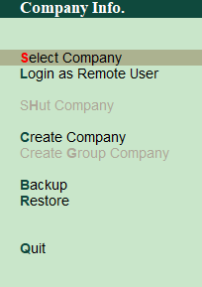Once Tally ERP 9 is open, The Company Info interface will appear. It includes the following features:

1. Select Company
2. Login as Remote User.
3. Create a company.
4. Backup.
5. Restore.

This tab allows you to create as many companies as needed as well as select created companies.

## **Tally Home Screen**

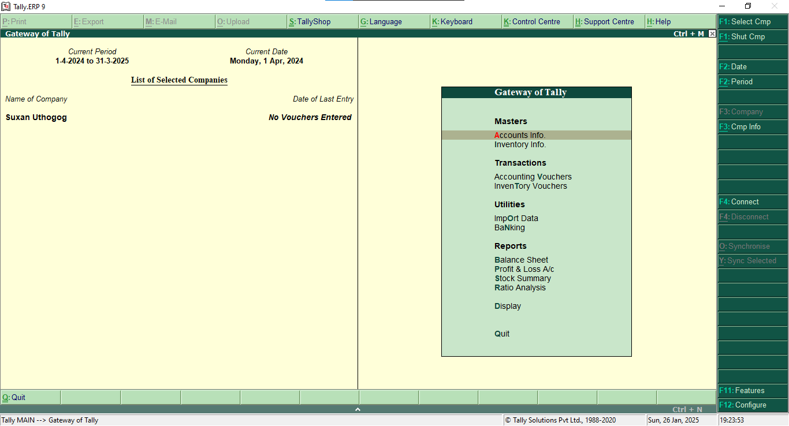

## **Accounts info**

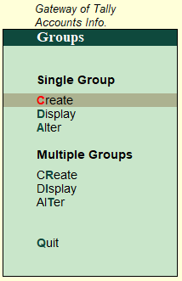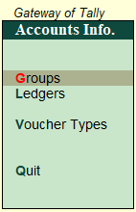

The Ledger function can be used to generate new ledger accounts for use in future entries and vouchers.

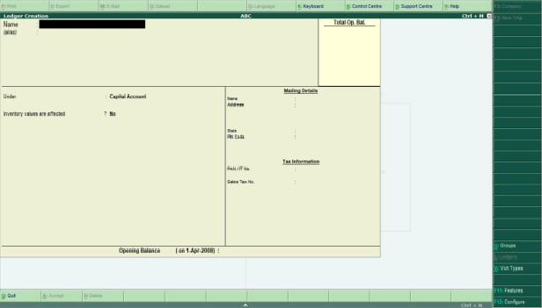

## **Inventory info**

# **Creating a Company**

1. Go to Gateway of Tally
2. In Company info we can see Create Company
3. Select it, Company creation window will appear.
4. At last, the message Accept? Yes/ No will Displayed.
5. Press Enter or Y to save the details

Name: Kusum Karkhana

Mailing Address: Aargakhachi, Nepal

Contact No: 01-5588996

Email: karkhanakusum@gmail.com

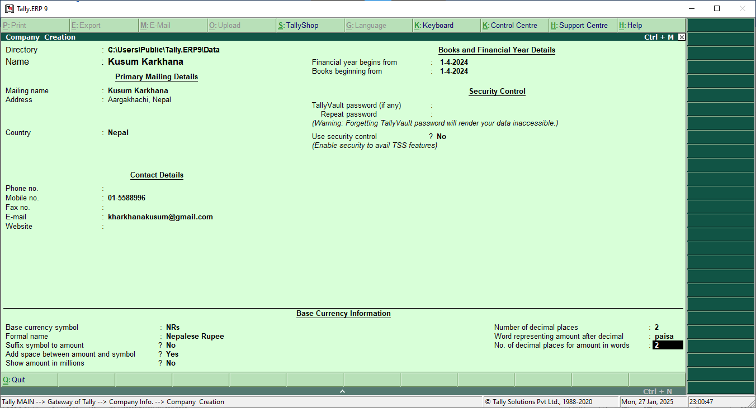

# **Ledgers**

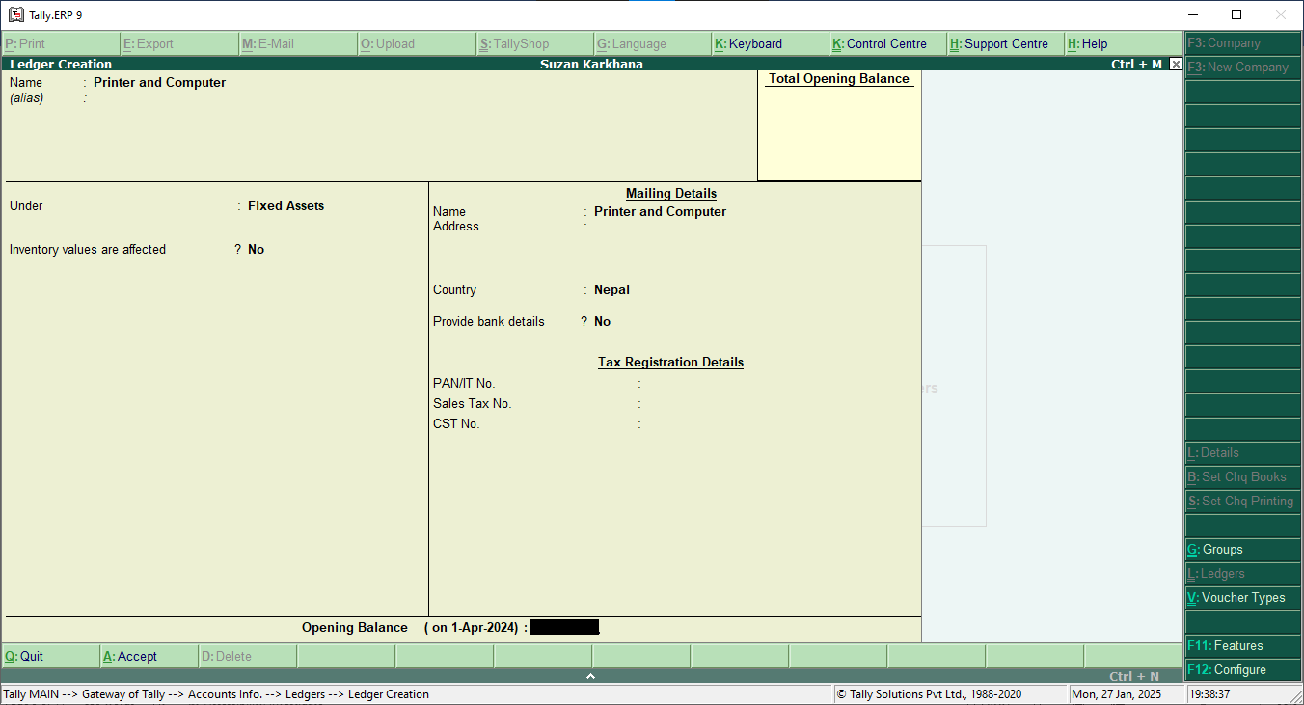

**List of Ledger**

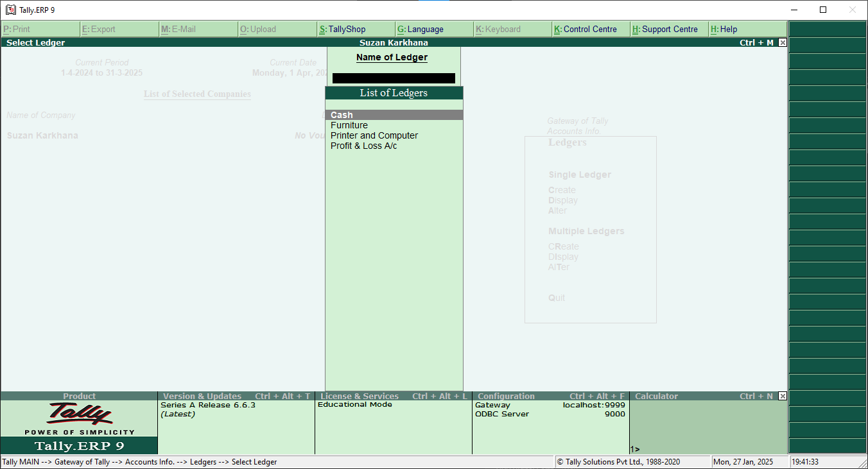

***Note: While making leger, by default two ledger are created in tally (i.e. cash A/C and Profit and loss A/C).***

# **Voucher Entry**

In accounting terms, a voucher is a document containing the details of a financial transaction. For example, a purchase invoice, a sales receipt, a petty cash docket, a bank interest statement and so on. For every such transaction made, a voucher is used to enter details into the ledger to update the financial position of the company.

## **Receipts**

Being business started with cash Rs 20000 and Furniture Rs 50000

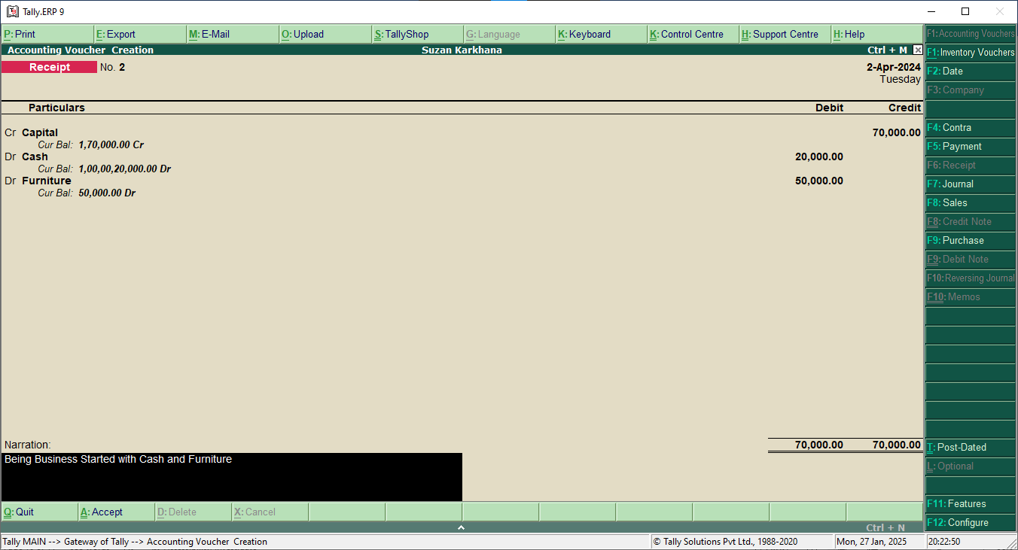

## **Payments**

Rent paid to house owner Rs 5000

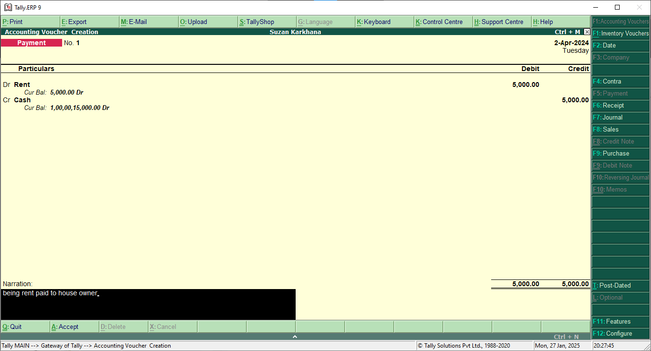

## **Contra**

Cash Rs 50000 deposited into Mero Bank.

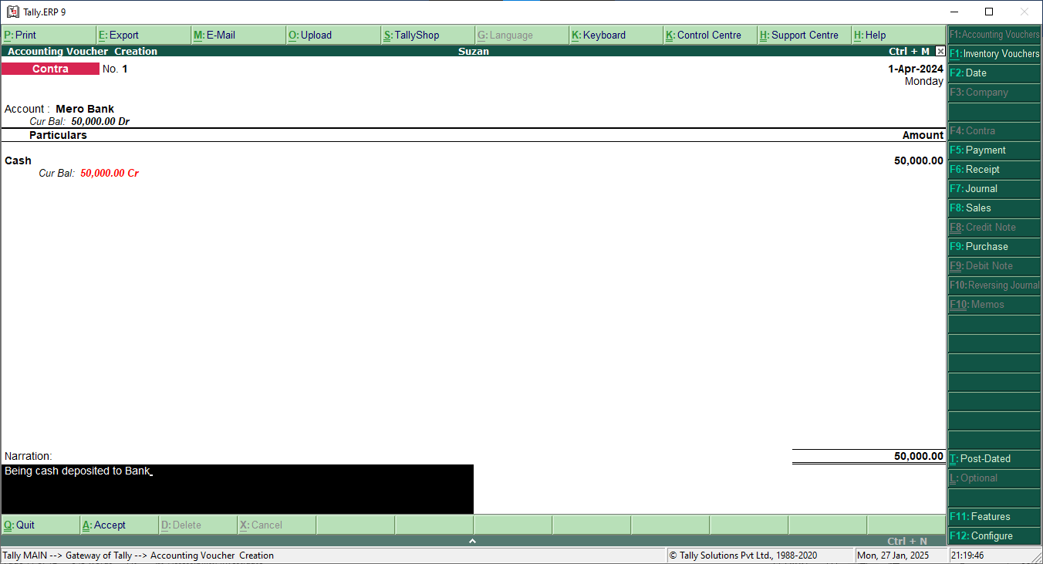

## **Purchase**

Goods Purchased Rs 20000

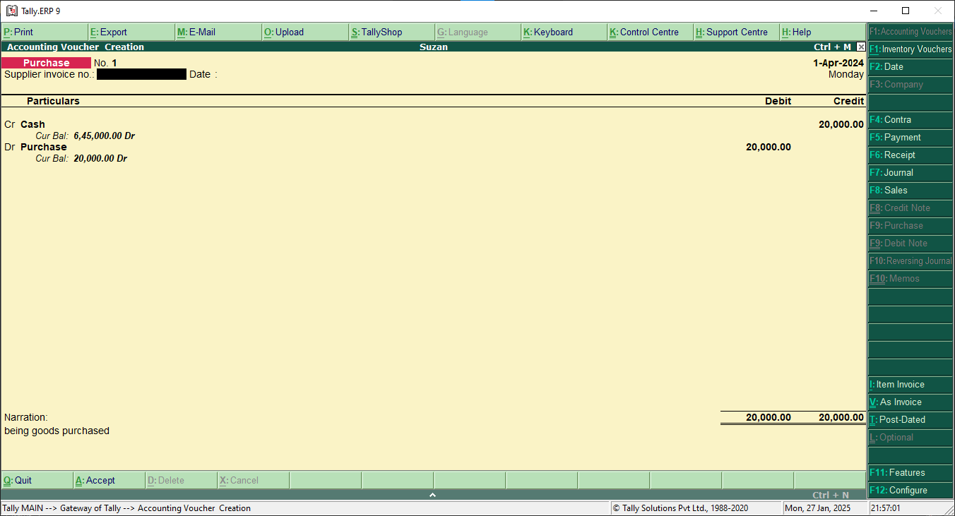

## **Sales**

Goods sold costing Rs 5000 on cash

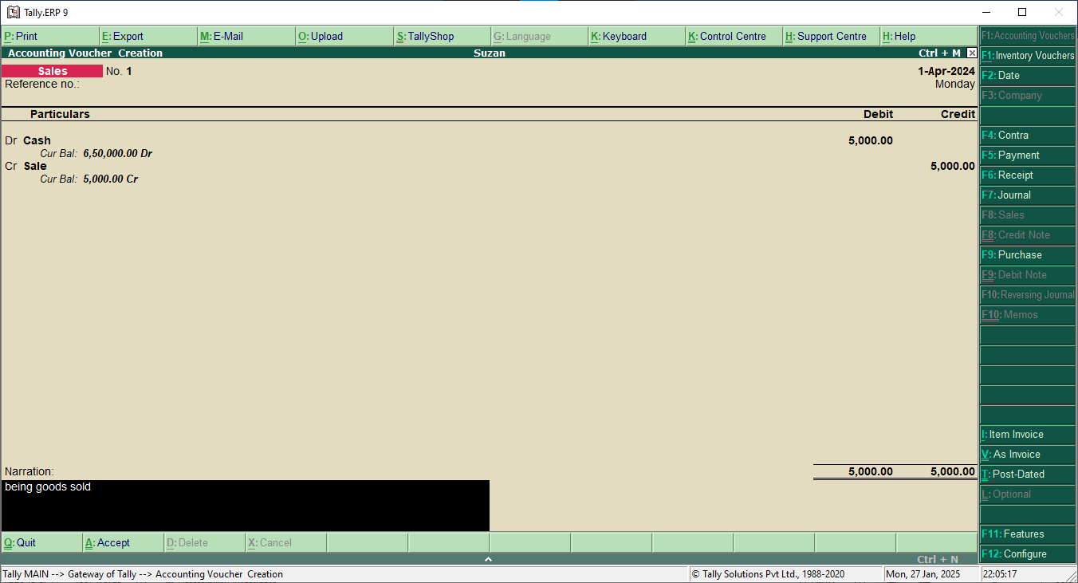

# **Trial Balance**

Showing the transaction into the trial balance.

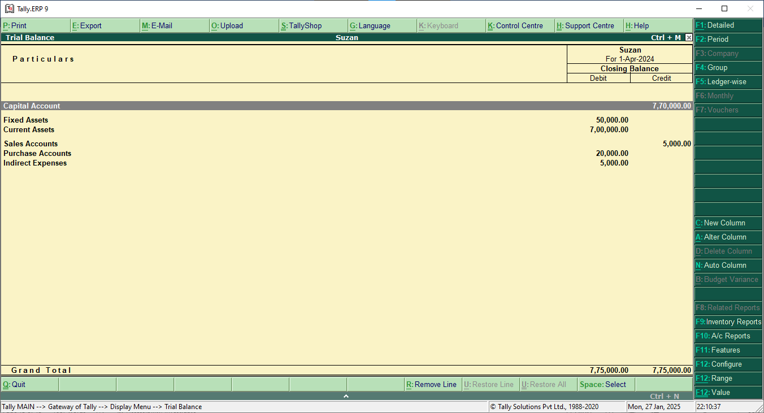

# **Profit and loss account**

Showing the transaction into the profit and loss account.

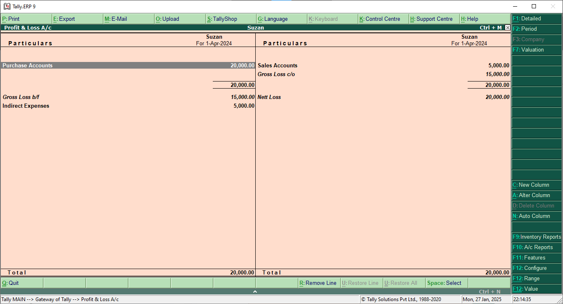

# **Balance sheet**

Showing the transaction into the balance sheet

